­­­

The following example for Part2 achieved a merit grade

Remember: Appendices 1 & 2 are required and are part of the marks.

There is no need for your own work to use the same format, style or exact contents, but the example might be helpful.

The references have been removed

Please be aware that directly copying any part of the work will result in TurnItIn matching for plagiarism

**INTRODUCTION**

We live in a world that’s not perfect, a world where it takes time for teams to work effectively. In a perfect world new team members work together smoothly day and night from day first, communicate well, productively focus on team’s goal and get along (ref). Critical reflection is a skill that can be learned through practice and feedback and learning this skill may vary from person to person it may take a person few days to learn and sometimes a year for another (ref). It is a meaning making process that helps us use what we have learned in the past to perform future actions, consider the real life implications of our thinking and set goals. Critical reflection is the link between thinking and doing, and at its best, it can be transformative (ref). Engaging in it helps us articulate questions, confront bias, examine causality, contrast theory with practice and identify systemic issues all of which helps foster critical evaluation and knowledge transfer (ref).

This project helped me a lot in polishing my skills as project manager as it was my first experience as project manager. I have gained a lot of experience from this project, not only that I have come to know many of my strengths and weaknesses (that I need to work on). I was able to manage all the challenges that rose while I was completing the project. In the project we two members and we both were project managers, my partner was managing the issues with stake holders while I was working on the leaderships issues. Managing leadership issues gave me a very tough time and that demotivated me at times but it was managed at the end.

In leadership issues I faced three main issues:

1. Understanding and managing change impact on team specially senior staff
2. Understanding team needs and motivation
3. Team development

The team and staff of Khanpur College of technology (KCT) has been teaching through conventional face to face method since a long time and the senior staff were not ready to accept digitization in their college and teaching method. They wanted to take all classes through conventional method, the face to face class, they saw this as a threat to their jobs specially the senior teachers as they were quiet aged and working with technology was very difficult for them. They feared that the digitization might take their job as the college may appoint new teachers who are good with technology, and only their fear was the reason that kept them going and they kept trying. Being my first project as manager I failed to understand their needs and motivations, I was forcing it on them without thinking about their needs, my team member made me realise that I have to fulfil their needs and then work with them. I assessed their needs and motivations and noticed that their biggest fear was losing their jobs as they were old and being jobless at that age was nightmare for them. I assured them their jobs hence fulfilling their needs and they worked happily and highly motivated. At start it was an issue for me to develop a highly motivated team as there were many of their needs that were not fulfilled and I failed to clarify the goal to them.

**Application Of Kubler-Ross Change Model**

In order to grow an organization must bring some changes, but implementing changes on someone/somewhere is a very difficult task. Changes can be traumatic for many as the changes may not be in their favour, some even go through series of reaction that are similar to dealing with grief. Psychiatrist Elisabeth Kubler-Ross came up with the Kubler-Ross change model in 1969 in her book “Death and Dying” (ref). The change curve describes these stages (as shown below).

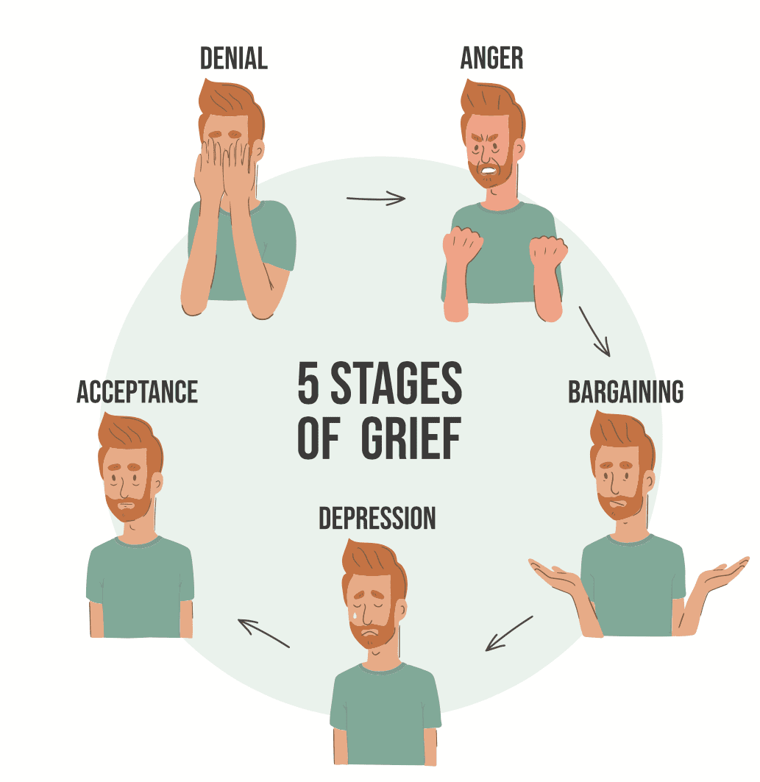

Figure 1: Kubler-Ross change model (ref)

While dealing with challenges, I noticed that the Kubler-Ross change model was applied both to me, as a team leader, and to my team.

While going towards digitization my team went through the following stages:

1. Denial: the team members specially the senior and aged were not ready to accept the fact that things are going to change from face to face class to online classes. They were in denial that there is no need of online classes and that everything will come back to normal soon. They were not ready to accept the fact that digitalization is the future of not only education but every field.
2. Anger: once they were out of the denial phase they got frustrated and angry that covid has already given them a lot of loss and that now digitalization will take their jobs as they are not experienced and hardly know much about latest trends in technology and its latest trends. Their anger was justified as they were thinking that due to less knowledge about technology they might lose their job.
3. Bargaining: they agreed to digitalize all the system after they were giving assurity through bargaining, they would be taught about latest technology, markets trends along with all the important courses that are needed in digitization of education. The team would go towards digitalization and they can keep their jobs.
4. Depression: the team went into depression as they have to learn new techniques at this old age and yet they feared of failure and their jobs, although assurity was given to them.
5. Acceptance: the team accepted the fact that they can only survive and keep their jobs if they go towards digitization and learn its techniques, so they starting working as we wanted.

While going towards digitization I went through the following stages:

1. Denial: at first when digitalization was introduced to them it was a huge change for them but I was in the denial that why won’t they accept it? And it’s the basic education needs so they will have to accept it, although they had already rejected it.
2. Anger: as they were not accepting digitization I got angry and frustrated that they have to accept the new ways of teaching as its how its going across the world and they are rejecting it.
3. Bargaining: a bargaining was done that they can keep their jobs but they have to work with the latest trends in educational sectors and take all training as we wanted to which they agreed to.
4. Depression: I went into depression phase as what if they are not able to cope up with the latest gadgets and technology, which may result in failing of my project.
5. Acceptance: at last they accepted the fact that digitalization is important and I accepted the fact that they will be able to learn how to handle the gadgets, which made me stress free.

**Why Is Being A Good Communicator Important?**

It is very important for a project manager to be a good communicator to ensure fulfilments of objectives and better understanding of requirements. The human brain is naturally programmed for survival and responds to changes where it feels any impact whether physical or social. The senior staff member of KCT saw digitalization as a threat to their old conventional experience of teaching.

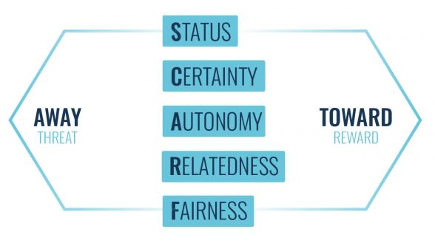

Figure 2: Scarf model (ref)

The SCARF model explains five factors that brain is always monitoring and has a major impact on how we behave, it can take us towards our goal and getting reward or away from goal towards threat. SCARF factor helps project managers for better leadership response to manage change in impacts:

* Status: senior staff see this change as impact on their status and esteem as senior staff , as senior staff is having the perception of being considered lower than others due to lack of digital knowledge and digital skills.
* Certainty: senior staff predict digitalization as a risk to their job as they have always been doing it the conventional way.
* Autonomy: senior staff will not be much confidence on what they are doing as they do not feel control and authority over the situation.
* Relatedness: senior staff feels unfit with digitization and online learning tools as they sense that they do not belong there , they are happy with face to face teaching method.
* Fairness: digitalization of teaching method and its future created doubts in senior staff who were outdated in terms of technology so it was a bit unfair to them.

In Scarf factor it can be seen that senior staff sensed a lot of changes which did not go in their favor thus resulting in avoidance response.It is essential for every project manager to understand team needs and motivations. Maslow’s hierarchy of needs explained that people are motivate by basic needs and then higher level unsatisfied needs (ref).

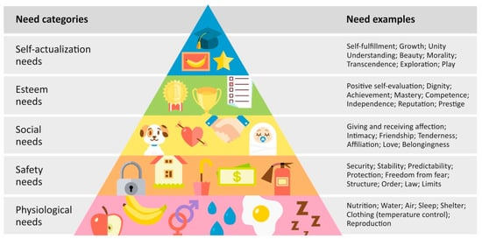

Figure 3: Maslow's Hierarchy of Needs (ref)

In my case study I would be using these 2 need categories from Maslow’s hierarchy of need theory only:

* 1. Safety needs: Due to lack of digital skills senior staff saw their jobs at risk.
  2. Esteem needs: due to low or no experience in technology, staff with old techniques see their dignity and mastery at risk.

Project manager and his team do not have any direct or long term management responsibility and authority at all. They just achieve big goals by just making acceptable changes in order to motivate team to deliver larger outcomes (ref). In this case job security is the highest motivation for the senior staff. After getting job security they will be highly motivated for the training and skills development programs that your team has arranged for them. After the training are complete recognize the esteem needs of the senior staff by recognizing technical skills and experience of senior staff and ensure value of technical skills of senior staff which will add even more benefit to the digital learning experience , as their experience in teaching and digitization will help the students in many way.

**Tuckman Team Development And Extension To Tuckman’s Model**

Tuckman team development model (ref) is used to better understand stages of how a team goes throughout a journey from becoming a simple team to a high performing team.

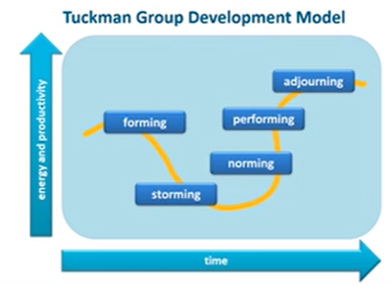

Figure 4: Tuckman Group Development Model

Our project is considered in the storming stage and it is a known fact that most of the project does not go beyond this phase. To achieve my goal I have to take the project to performing phase as soon as possible.

Extension to the Tuckman’s model (ref) divides development in 4 phases:

1. Get set: this is the starting point where foundation of a project is laid. The purpose and goals of the project is discuss and explain to the team, giving them a clear picture about the project thus creating clarity of goals to them. Project manager will Communicate and align with stake holders in this phase.
2. Get safe: in this phase team members will start working on the roles and responsibility assigned to them. The team member will be working together accepting each other as team member and creating a better safe work place.
3. Get strong: in this phase manger can take risks and do new experiments to innovate. He has to keep the team motivated. Hold the team member accountable for the tasks they will are responsible for.
4. Get success: this is final phase where the project is completed and delivered to the stakeholders.

In this project the team got success as the senior staff worked as a team after getting job assurity. The major reasons that the project got through the forth phase was that the goals were clear to all the team members and they had a grip on the responsibilities that were assigned to them. The team worked together as one strong team helping each other and facing every problem as a team. New experiments were also done and risks were taken but due to highly motivated team members the experiments were successful. Although the project was delivered late but it was delivered with perfection.

**Conclusion**

This project has thought me alot of things, I have experienced new challenges, worked with new team and learnt my weaknesses and strengths that were unknown to me. It is clear that there are few initiatives that a project manager has to take to achieve this goal:

1. Understanding team needs
2. Motivate team members
3. Clear goals and objectives
4. Build team trust
5. Provide learning and development opportunity to leaning new digital techniques
6. Provide technical support for digitalization.

We as a team achieved our goal because once their needs (job assurity) were fulfilled they worked really hard, they got motivated and started doing their work with extra efforts. As there was clarity about the goals to them they did not have any issue achieving it and it was one of the main reason that the project was successful. Team members respected each other and at times helped others in their roles. The senior staff lacked in working with technology but the other team members helped them in each and everything, they were even taught new methods and techniques. Sessions and workshops were arranged for them to have a good grip on topic. Better team performance depends upon Input and feedback they receive to review and align their performance with team objectives (ref).

References

‌

**Appendix 1**

**Peer review assessment Questionnaire**

Participant 1: Myself

I have awarded myself 4/10 marks for my contribution to the team development and leadership because overall I failed to manage the team but one way or the other i achieve my goals. Despite very few resources and lack of interest of my team members at start I was able to complete the project one month after the due date. As it was my first project as project manager it took me time to settle and understand my team. I was highly motivated at start of the project but seeing the non-seriousness of my team members I failed to deliver the way I thought of. I was unaware of the expertise of my team members at start which engaged me in a conflict over roles.

Participant 2: Name

I have awarded Name 10/10 marks for his contribution to the team development because he really had the team on his back. He was quiet experienced and according to me he deserved to me the project manager. He helped all team members and did all his work on time. He was always open to discussion and contributed in every task even if wasn’t his. He worked late nights as well which showed his commitment to the project. Name’s contribution to the project was the highest of all. He was the role model for team members who had their debut and he had a great role in resolving conflict between team members.

Participant 3: Name

I have awarded Name 7/10 marks for his contribution to the team development because it was his debut project and he did more than I was expecting from him. Being in a team for the first time he was really motivated and worked really hard. He was able to complete all task assigned to him on time but wasn’t able to take extra load due to lack of experience. He was really devoted to team but lack of experience left him behind from other team members.

Participant 4: Name

I have awarded Name 3/10 marks for his contribution to the team development because he was working in two teams of different projects which made his attention diverted and he was giving very less time to my project. He would arrive late regularly and would leave early as the other project seemed first priority. He did not completed any of the assigned works on time although he was given warnings again and again. He had conflict over many things with other team members and was never open to discussion he did what he thought was right and expected others to go his way. He had no work ethics so it was really hard to interact with him.

**Appendix Two**

**Professional Development Plan (PDP)**

**Part 1: Personal Analysis**

|  |  |
| --- | --- |
| **Strengths** | **Areas of further development** |
| * Generous with credits to others * Strong business sense * Empower new recruits * Efficient communication skills * Negotiation skills | * Time management * Conflict resolution * Too detailed oriented person * Bad motivator |
| **Opportunities** | **Threats** |
| * Training in marketing * Leadership training * Quality assurance training | * Balancing work and family time |

**Part 2: Setting Goals**

|  |  |  |  |  |
| --- | --- | --- | --- | --- |
| **What do I want to learn?** | **What support and resources will I need?** | **What do I have to do?** | **What benefits will I get?** | **Target time for review?** |
| Time management | Set routine and follow it strictly.  Read books and articles on time management. | Keep record of work I do and observe the time regularly | Time management will help me complete my projects on time or before time so that I can start new project without and burden from previous project | Three months from now |
| Conflict management | Read books and listen to lectures on conflict management | Apply the lessons from book or lecture in real life | It will give me a good edge as project manager as it’s the most important factor in managing a team | 5 months from now |
| Be a Motivator | Listen to all good motivators regularly , attend their sessions, go to workshops and read anything you find on motivation | Try to motivate anyone who is around you; known or unknown | It will help me a lot as a team manager as I would be able to motivate them in many aspects which will help my team to progress | 2 months from now |
| Pay less attention to unnecessary things(be less of a detailed oriented person) | Keep a check on yourself and ask friends and family to remind you if you are being detailed oriented in anything | Keep yourself busy in your work and do only things that are important and essential, | Being less detailed oriented person will let me think about things in different aspects and will help me in look at the bigger picture then to worry about small things. | From today |

**Part 3: Personal Objectives**

|  |
| --- |
| **Short-Term (next 12 months)** |
| Complete master’s degree and get Project Management Professional (PMP) certification. Go to project management workshops and lectures and learn from different people. |
| **Medium-Term (next 2-3 years)** |
| Be part of one of the top leading firms even if it’s just being a team member of any of their project and gaining knowledge and experience from it. |
| **Long-Term (beyond 3 years)** |
| Do PHD in project management, be on top post in one of the top industry of Pakistan that works for the betterment of the country .Manage and own a Non Profitable Organization (NGO). |